**“Vehicle Speed Estimation Using Object Detection and Tracking”**

**Minor Project Report**

***in partial fulfilment for the award of the degree***

***of***

**BACHELOR OF ENGINEERING**

***in***

**COMPUTER SCIENCE & ENGINEERING – Data Science**

**DEPARTMENT OF COMPUTER SCIENCE AND ENGINEERING**

GYAN GANGA INSTITUTE OF TECHNOLOGY & SCIENCES

JABALPUR (M.P.)

RAJIV GANDHI PRODYOGIKI VISHWAVIDYALAYA,

BHOPAL (M.P.)

**April- 2022**

**CERTIFICATE**

This is to certify that the Minor Project report entitled “**Vehicle Speed Estimation Using Object Detection and Tracking**” submitted by **Akshit Narang** has been carried out under my guidance & supervision. The project report is approved for submission towards partial fulfilment of the requirement for the award of degree of **BACHELOR OF ENGINEERING** in **COMPUTER SCIENCE & ENGINEERING** from **RAJIV GANDHI PROUDYOGIKI VISHWA-VIDYALAYA, BHOPAL (M.P).**

|  |  |
| --- | --- |
| Mr. Jitendra Prithviraj  Guide  **Dept. of Computer Science and Engineering** | Dr. Ashok Verma  HoD  **Dept. of Computer Science and Engineering** |

#### CERTIFICATE

This is to certify that the Minor Project report entitled “**Vehicle Speed Estimation Using Object Detection and Tracking**” submitted by **Akshit Narang** has been carried out under my guidance & supervision. The project report is approved for submission towards partial fulfilment of the requirement for the award of degree of **BACHELOR OF ENGINEERING** in **COMPUTER SCIENCE & ENGINEERING** from **RAJIV GANDHI PROUDYOGIKI VISHWA-VIDYALAYA, BHOPAL (M.P).**

Internal Examiner External Examiner

Date: Date:

#### DECLARATION

We hereby declare that the project entitled **“Vehicle Speed Estimation Using Object Detection and Tracking”** which is being submitted in partial fulfillment of the requirement for award of the Degree of Bachelor of Engineering in Computer Science and Engineering to **“RAJIV GANDHI PROUDYOGIKI VISHWAVIDYALAYA, BHOPAL (M.P.)”** is an authentic record of our own work done under the guidance of **Mr. Jitendra Prithviraj, Associate Professor, Department of Computer Science & Engineering,** **GYAN GANGA INSTITUTE OF TECHNOLOGY & SCIENCES, JABALPUR**.

The matter reported in this Project has not been submitted earlier for the award of any other degree.

**Date:**

**Place: JABALPUR**

#### ACKNOWLEDGEMENT

We sincerely express indebtedness to esteemed and revered guide **Prof. Jitendra Prithviraj, Assistant Professor, Department of Computer Science and Engineering**for his invaluable guidance, supervision, and encouragement throughout the work. Without his kind patronage and guidance, the synopsis would not have taken shape.

We take this opportunity to express deep sense of gratitude to Dr. **Ashok Verma, Head of Department of Computer Science and Engineering**for his encouragement and kind approval. Also, we thank him in providing the computer lab facility. We would like to express our sincere regards to him for advice and counselling from time to time.

We owe sincere thanks to all the faculty members of Department of Computer Science and Engineeringfor their advice and counselling time to time.

**Date:**

**Place: JABALPUR**

**TABLE OF CONTENTS**

1. INTRODUCTION................................................................................................................7

2. Requirement Analysis.....................................................................................................7

2. RELEVANCE........................................................................................................................7

3. OUTCOME..........................................................................................................................8

4. PROBLEM STATEMENT....................................................................................................8

4.1 Vehicle Detection................................................................................................................8

4.2 Speed Estimation................................................................................................................9

4.3 Capturing Vehicle Image....................................................................................................10

5. PROJECT MODEL.............................................................................................................10

5.1 Video Acquisition..............................................................................................................10

5.2 Region of Interest and Masking.........................................................................................11

5.3 Contour Detection and Object Tracking............................................................................12

5.4 Speed Estimation...............................................................................................................13

5.5 Save Vehicle Data..............................................................................................................13

5.6 Create Summary................................................................................................................14

6. IMPLEMENTATION.........................................................................................................15

6.1 Video Acquisition..............................................................................................................15

6.2 Region of Interest and Masking.........................................................................................15

6.3 Contour Detection.............................................................................................................16

6.4 Object Tracking..................................................................................................................16

6.5 Speed Estimation...............................................................................................................16

6.6 Drawing Rectangles and displaying on the screen............................................................17

6.7 Save Vehicle Images and speeds.......................................................................................17

6.8 Create Summary................................................................................................................17

7. OUTPUT SCREENSHOTS................................................................................................18

7.1 Speed Detection................................................................................................................18

7.2 Saved Image Pictures.........................................................................................................19

7.3 Saved Vehicle Data............................................................................................................19

8. RESULTS ANALYSIS..........................................................................................................19

9. CONCLUSION...................................................................................................................20

10. ACKNOWLEDGEMENT.................................................................................................20

11. REFERENCES..................................................................................................................21

**LIST OF FIGURES**

Figure 1: Vehicle Detection Block Diagram................................................................................9

Figure 2: Speed Timer Diagram.................................................................................................9

Figure 3: Project Model Block Diagram ..................................................................................10

Figure 4: Sample Video Screenshot.........................................................................................11

Figure 5: Masked Image..........................................................................................................11

Figure 6: Contour Detection ...................................................................................................12

Figure 7: Speed Estimation......................................................................................................13

Figure 8: Saved Vehicle Pictures..............................................................................................13

Figure 9: Saved Summary........................................................................................................14

Figure 10: Speed Radar Main Output......................................................................................18

Figure 11: Saved Vehicle Images.............................................................................................19

Figure 12: Summary of Vehicles..............................................................................................19

1. INTRODUCTION

Initially a Doppler radar was used to capture the speed of Vehicles on roads. Cameras were used to capture speeding vehicles. A Doppler radar uses the change in frequency of a passing vehicle to determine the speed of the vehicle. (This phenomenon is known as Doppler effect).

Later Traffic Radars started using sensors to detect speeds. At present, traffic radars integrate the use of sensors and image processing to catch traffic violators.

The traffic violation need not be speeding, it can also be wrong/reserved lane detection, passing the red-light detection, tailgating, wrong side overtaking etc.   
   
In the future, traffic radars may even detect seatbelts and texting while driving offences. Such work is currently under research and may come out soon.

2 Requirement Analysis

2.1 Functional Requirements

* Reporting Requirements – These are the information and data that an individual must supply to government agencies in case of any ill practices or law violation is found.
* Historical Data Management – This includes how the log files will be handled which includes the data of the vehicles passing by along with the time stamps.

2.2 Non-Functional Requirements

* Compatibility – Throughout the development of the project it must be made sure that the minimum hardware requirements and software versions are compatible.
* Maintainability – With changing surveillance environment how easy it is to maintain the system.
* Usability – The system should be easy for people to interact with as it might not be handled by people who are tech savy.
* Performance – The performance aspect of the system is of utmost importance as the system would be deployed as a real-time solution and the response time and accuracy for detection and tracking should be ideal.

3. RELEVANCE   
   
Speeding Cameras are present in many highways to catch speeding vehicles and improve the safety on roads. Developed cities have more speed cameras and have more well monitored roads.   
   
Cameras today not only catch speed, but also register if a vehicle goes on the wrong lane or crosses a red light.   
   
If there are consequences to rash driving on roads (like road fines or license suspension), people would be more careful in following street rules. This in turn would reduce the number of accidents on the road.

4. OUTCOME   
   
This project would be able to successfully determine the speed of a vehicle and save the vehicle picture in a separate folder. Due to video clarity issues, number-plate detection is beyond the scope for this   
project.   
   
This project focusses on vehicle detection and tracking and speed estimation.

5. System Design

5.1 Design Goals

Following are the design goals for the project:

* Usability – The system should be easy to use for different user groups.
* Compatibility - Throughout the development of the project it must be made sure, that the minimum hardware requirements and software versions are compatible.
* Performance – The performance aspect of the system is of utmost importance as the system would be deployed as a real-time solution and the response time and accuracy for detection and tracking should be ideal.
* Efficiency – Reducing the number of resources consumed through design.
* Cost – Reducing the total cost of the project through efficient design.

5. PROBLEM STATEMENT   
   
The objective of this project is to create a traffic radar using Image Processing in Python by using OpenCV and TensorFlow.   
When it comes to tracking the speed of vehicles on a segment of road, the vital steps of this projects are:   
   
• Vehicle Detection   
• Speed estimation   
• Capturing vehicle picture

5.1 Vehicle Detection   
   
As the background of the vehicles is stationary (as the speed camera is stationary) image subtraction is used to detect moving vehicle.

Figure 1: Vehicle Detection Block Diagram

5.2 Speed Estimation   
   
The speed of a vehicle can be estimated when a tracked vehicle covers a segment of road.   
Figure 2: Speed Timer Diagram

5.3 Capturing Vehicle Image   
   
Based on Contour detection, the image of a particular ID is saved to a folder along with the speed. Picture is saved as soon as the speed is estimated.

Figure 3: System Architecture

6.1 Video Acquisition

The video used in this project is a street view in Abu Dhabi. The number plates of the vehicle in the video are however not clearly visible.   
 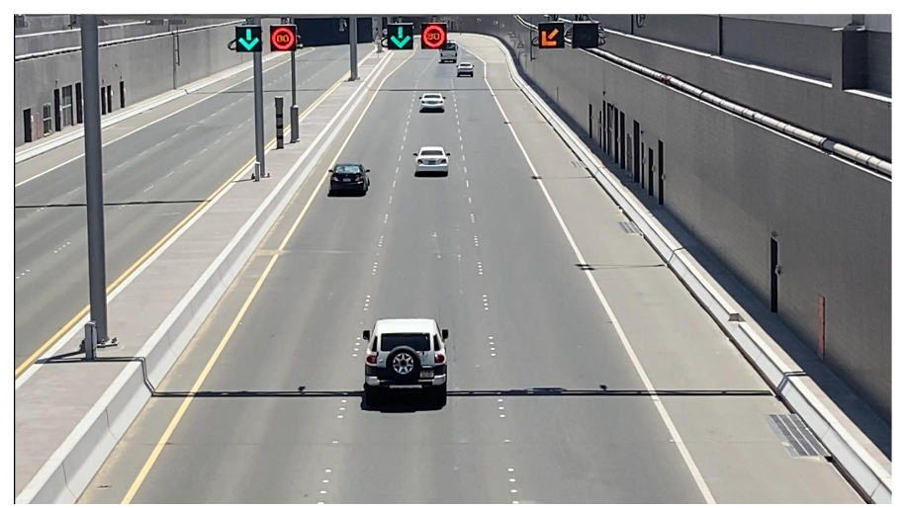  
 Figure 4: Sample Video Screenshot

6.2 Region of Interest and Masking

Region of Interest (ROI) takes a smaller portion of the original video. On this ROI, Image subtraction is performed to detect a moving vehicle. (Image Subtraction helps find the difference between two frames). Masking is performed to make the moving vehicles appear white and the rest of the image black.

Figure 5: Masked Image

6.3 Contour Detection and Object Tracking   
Based on the area threshold of number of pixels, the contours are detected. The threshold is used to avoid detecting contours of smaller moving objects that are not vehicles.

The object is tracked based on the distance between two contours between frames. An ID is assigned to each contour.   
   
 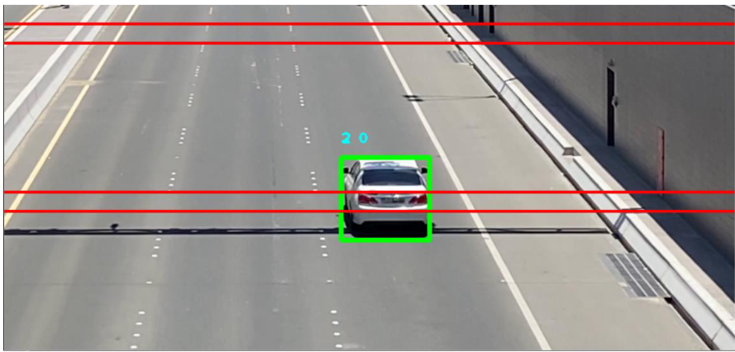

Figure 6: Contour Detection

6.4 Speed Estimation   
Time difference between the position of a vehicle is calculated and the speed is estimated based on a formula. The timer starts when the vehicle crosses the first line, and the timer ends when the vehicle crosses the second line.

The speed is displayed on top of the bounding box only when the vehicle crosses both the lines.

Figure 7: Speed Estimation

6.5 Save Vehicle Data   
The picture of the bounding box (the vehicle) is saved into a file along with the speed. Vehicles crossing the speed limit is segregated into a separate folder.   
   
Figure 8: Saved Vehicle Picture

6.6 Create Summary   
   
The vehicle data is saved in a text file. The vehicles that exceeded the speed limit are pointed. A summary of number of vehicles and the speed violators are displayed.

Figure 9: Saved Summary

**7. Work Done**

* 1. **Development Environment**
     1. Software Requirements:
* Python version 3.7
* OpenCV
* Jupyter Notebook
* Google Colab
  + 1. Hardware Requirements:
* Intel i5 10th Gen or above OR AMD Ryzen 3750H or above
* 16GB RAM or above
* Nvidia GTX 1660ti or above • Camera recording at 30fps or above

**7.2 Implementation**

* Video Acquisition

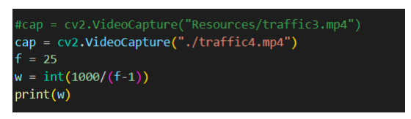

* Region of Interest and Masking

* Contour Detection

* Object Tracking

* Speed Estimation

* Drawing Rectangles and displaying on the screen

* Save Vehicle Images and speeds

* Create Summary

8. OUTPUT SCREENSHOTS

8.1 Speed Detection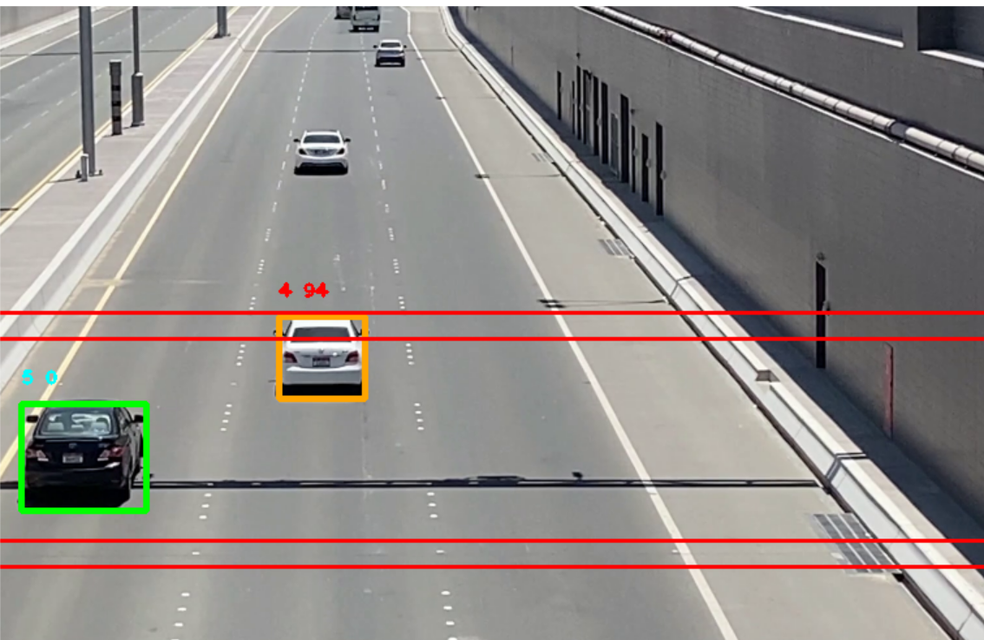

Figure 10: Speed Radar Main Output

8.2 Saved Image Pictures

Figure 11: Saved Vehicle Images

Figure 12: Summary of Vehicles

9. RESULTS ANALYSIS

This project is successfully able to track vehicles and estimate their speed. Accuracy in detecting vehicles is 100% if there is no movement in the camera. Estimation of speed can have a difference of 0-2 km/hr depending on the program execution speed.

Multiple vehicles can be detected, and their speeds can be detected. However, if two vehicles are moving extremely close to each other, it may be detected as a single object.

This project requires the camera to be as still as possible, as movement is used to distinguish vehicles from the background.

10. CONCLUSION

Road safety is an important factor for the police force. And as citizens it is our responsibility to follow rules and maintain safety on our roads. This project can estimate speed of vehicles and save vehicle data. Future Improvements can be finding other violations like wrong lane detection and tailgating detection.

11. ACKNOWLEDGEMENT

I would like to thank Prof. Vikas Dubey, for his guidance and support throughout the entire project and for giving me the opportunity to explore deeper into Image Processing Concepts both theoretically and practically.

12. REFRENCES

Determining vehicle speed based on video using convolutional neural network

<https://www.sciencedirect.com/science/article/pii/S2352146520307705>

Detection of Vehicle Position and Speed using Camera Calibration and Image Projection Methods

<https://www.sciencedirect.com/science/article/pii/S187705091931083X>

Vehicle speed measurement model for video-based systems

<https://www.sciencedirect.com/science/article/pii/S0045790618317774>

An Efficient Approach for Detection and Speed Estimation of Moving Vehicles

<https://www.sciencedirect.com/science/article/pii/S1877050916311103>